**3. category product system**

**Use Case Diagram**

**C:\Users\User\Downloads\Untitled Diagram.png**

**Class diagram**

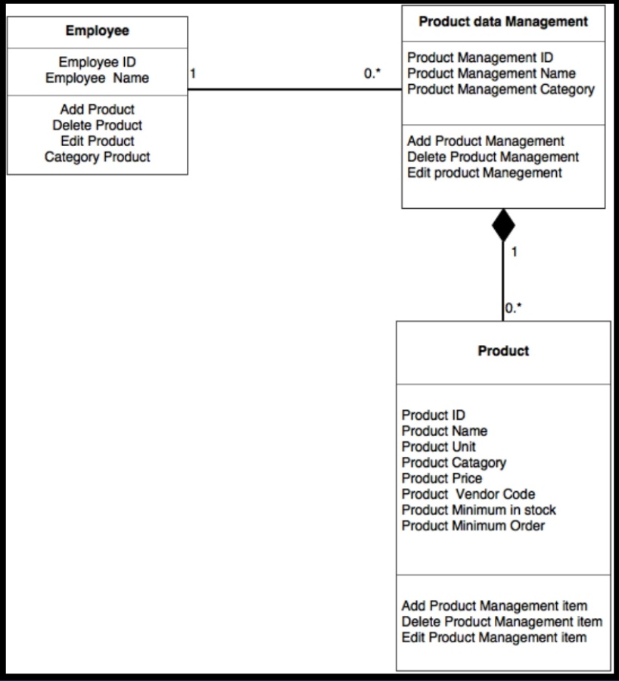

**Sequence Diagram demonstrating operation “Add product”**

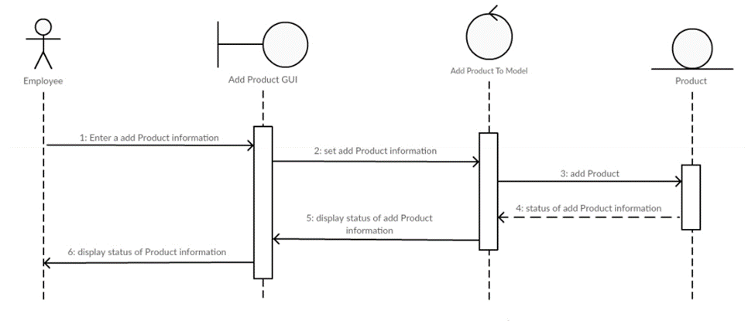**Sequence Diagram demonstrating operation “Delete product”**

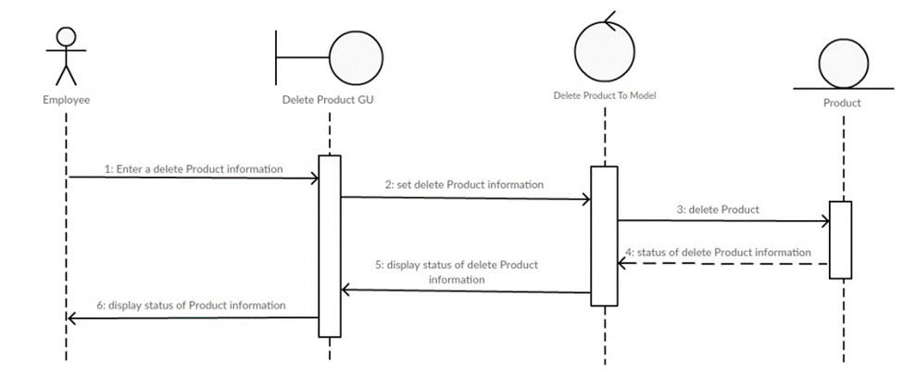

**Sequence Diagram demonstrating operation “Edit product”**

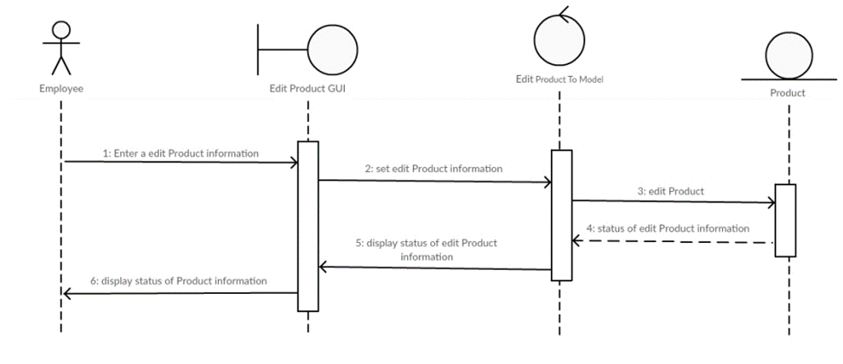

**Sequence Diagram demonstrating operation “View Report”**

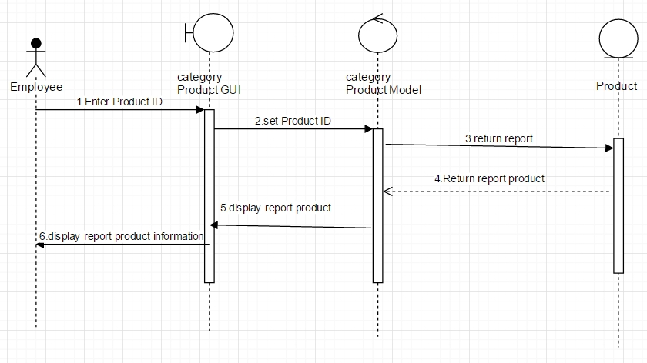

**Model-View-Controller (MVC) Model “Add Product”**

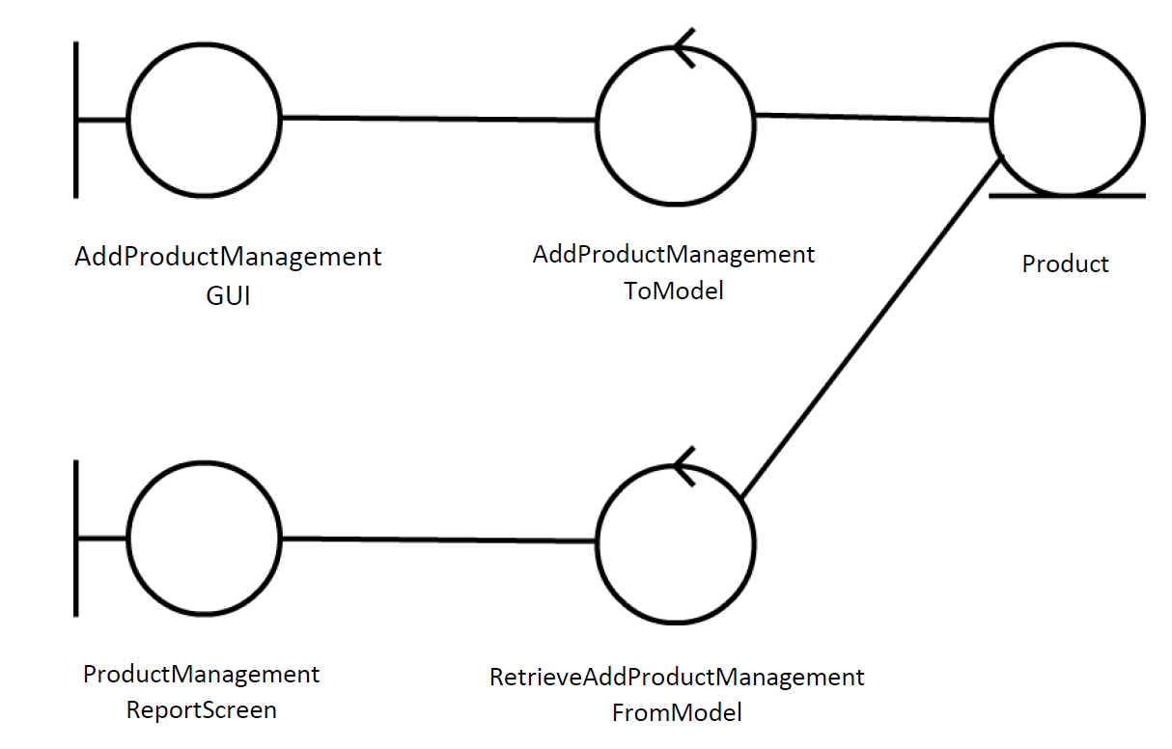

**Model-View-Controller (MVC) Model “Delete Product”**

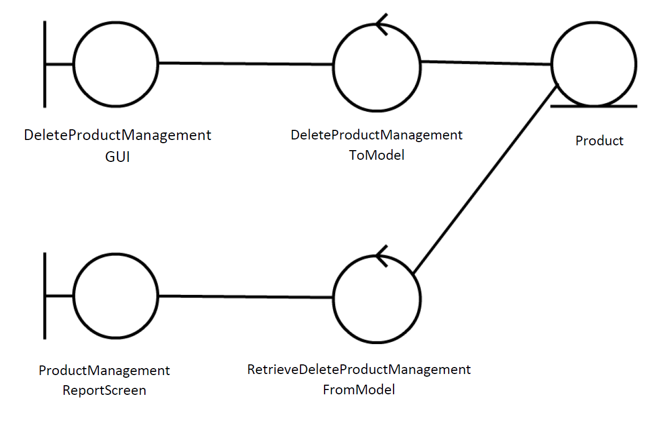

**Model-View-Controller (MVC) Model “Edit Product”**

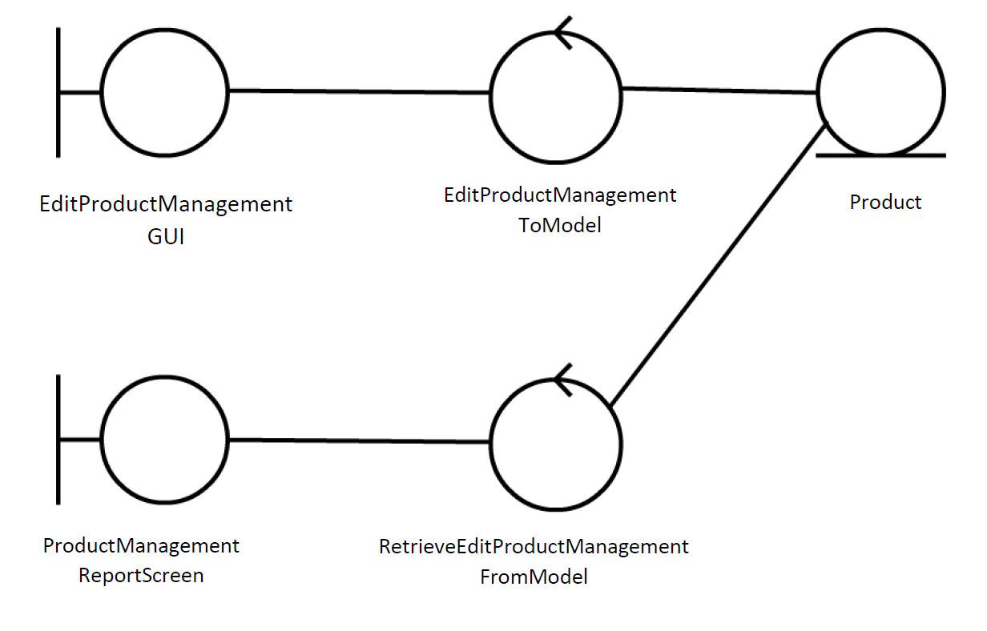

**Model-View-Controller (MVC) Model “Category Product”**

